|  |  |
| --- | --- |
| **Programme** | HND in Computing |
| Student Name | Mohamed Raaiz |
| ANC ID | 1001358 |
| Unit Number and Title | Unit 4: Database Design & Development |
| Academic Year | SU23 - 2023 |
| Unit Tutor | Thosanjith Medagoda |
| Assignment Title | Database design and development for Colourz |
| Issue Date | 08-July-2023 |
| Submission Date | 23-September-2023 |
| Submitted on | 23-September-2023 |

Student Declaration



Higher National Diploma in Computing

|  |
| --- |
| **Student declaration**  I certify that the assignment submission is entirely my own work and I fully understand the consequences of plagiarism. I understand that making a false declaration is a form of malpractice.  **Student signature**: **Date:** |

**Final Grade**

|  |  |  |
| --- | --- | --- |
| **Grade:** | **Assessor Signature:** | **Date:** |
| **Assessor Feedback:** | | |
| **Grade:** | **Assessor Signature:** | **Date:** |
| **Internal Verifier’s Comments:** | | |
| **Signature & Date:** | | |

**Learning Outcomes and Assessment Criteria**

|  |  |  |  |
| --- | --- | --- | --- |
| Pass | Merit | | Distinction |
| **LO1** Use an appropriate design tool to design a relational database system for a substantial problem | | | **D1** Evaluate the effectiveness of the design in relation to user and system requirements. |
| **P1** Design a relational database system using appropriate design tools and techniques, containing at least four interrelated tables, with clear statements of user and system requirements. | **M1** Produce a comprehensive design for a fully-functional system, which includes interface and output designs, data validations and data normalisation. | |
| **LO2** Develop a fully functional relational database system, based on an existing system design | | | **LO2 & LO3**  **D2** Evaluate the effectiveness of the database solution in relation to user and system requirements, and suggest improvements. |
| **P2** Develop the database system with evidence of user interface, output and data validations, and querying across multiple tables.  **P3** Implement a query language into the relational database system. | | **M2** Implement a fully functional database system which includes system security and database maintenance.  **M3** Assess whether meaningful data has been extracted through the use of query tools to produce appropriate management information. |
| **LO3** Test the system against user and system requirements | | |
| **P4** Test the system against user and system requirements. | | **M4** Assess the effectiveness of the testing, including an explanation of the choice of test data used. |
| LO4 Produce technical and user documentation | | | **D3** Evaluate the database in terms of improvements needed to ensure the continued effectiveness of the system. |
| **P5** Produce technical and user documentation. | **M5** Produce technical and user documentation for a fully functional system, including diagrams showing movement of data through the system, and flowcharts describing how the system works | |

**Higher Nationals - Summative Assignment Feedback Form**

|  |  |  |  |  |
| --- | --- | --- | --- | --- |
| **Student Name/ID** | Mohamed Raaiz/1001358 | | | |
| **Unit Title** | Database Design And Development | | | |
| **Assignment No** |  | **Assessor** |  | |
| **Submission Date** |  | **Date Received 1st submission** | |  |
| **Re-submission Date** |  | **Date Received 2nd submission** | |  |
| **Assessor Feedback:** | | | | |
| **Grade:** | **Assessor Signature:** | | | **Date:** |
| **Resubmission Feedback:** | | | | |
| **Grade:** | **Assessor Signature:** | | | **Date:** |
| **Internal Verifier’s Comments:** | | | | |
| **Signature & Date:** | | | | |

*\* Please note that grade decisions are provisional. They are only confirmed once internal and external moderation has taken place and grades decisions have been agreed at the assessment boar*

**Higher Nationals – Grading Rubric**

|  |  |  |
| --- | --- | --- |
| Grading Criteria | Achieved/Not Achieved | Comment |
| **P1** Design a relational database system using appropriate design tools and techniques, containing at least four interrelated tables, with clear statements of user and system requirements. |  |  |
| **M1** Produce a comprehensive design for a fully-functional system, which includes interface and output designs, data validations and data normalisation. |  |  |
| **D1** Evaluate the effectiveness of the design in relation to user and system requirements. |  |  |
| **P2** Develop the database system with evidence of user interface, output and data validations, and querying across multiple tables. |  |  |
| **P3** Implement a query language into the relational database system. |  |  |
| **M2** Implement a fully functional database system which includes system security and database maintenance. |  |  |
| **M3** Assess whether meaningful data has been extracted through the use of query tools to produce appropriate management information. |  |  |
| **P4** Test the system against user and system requirements. |  |  |
| **M4** Assess the effectiveness of the testing, including an explanation of the choice of test data used. |  |  |
| **D2** Evaluate the effectiveness of the database solution in relation to user and system requirements, and suggest improvements. |  |  |
| **P5** Produce technical and user documentation. |  |  |
| **M5** Produce technical and user documentation for a fully functional system, including diagrams showing movement of data through the system, and flowcharts describing how the system works |  |  |
| **D3** Evaluate the database in terms of improvements needed to ensure the continued effectiveness of the system. |  |  |

Activity 01 …………………………………………………………………………………………………

1. Introduction 7

2. Client's Requirements 7

3. Entity-Relationship Diagram (ERD) 7

4. Database Design 9

5. Normalization 10

6. Interface Design 10

7. Data Validation 19

8. SQL Queries 20

9. Evaluation and Performance 20

10. Security and Data Privacy 21

11. Backup and Recovery 21

12. Conclusion 22

Activity 02 23

**User Documentation** 23

**1.Graphical User interface** 23

**2. Investigating: Normal issues and their goals.** 29

**3. Backup and Recovery Procedures:** 29

**4.Maintenance Schedule:** 29

**Technical Documentation** 30

**1.Beginning Guide: Getting to the Java-Based Data set Framework** 30

**2. Flow Chart** 31

**3. Managing Potential Clients:** 33

**4.FAQs: Replies to potential client questions.** 34

**5. Data Flow Diagram (DFD)** 35

**7.Data Dictionary** 37

**8.Security Arrangements:** 38

**9.Scalability Plan:** 39

**10.Conclusion** 39

**11.Reference list** 39

**12.Turnitin Report** 40

**Comprehensive Design for a Relational Database System for Colourz**

# **1. Introduction**

# In the cutting edge business scene, information is the main impetus behind navigation and key preparation. Productive information the board is fundamental for organizations to acquire an upper hand. Colourz, an organization gaining practical experience in variety items, perceives the significance of a strong data set framework to smooth out their tasks and upgrade consumer loyalty. This report expects to give an itemized plan to a completely utilitarian social data set framework that meets Colourz's necessities and lines up with best practices in data set plan. A social data set framework sorts out information into tables with predefined connections between them. These connections guarantee information uprightness and work with information recovery and control. By actually overseeing item stock, client information, orders, and provider data, Colourz can work on its general effectiveness and settle on information driven choices

# .**2. Client's Requirements**

# In the cutting edge business scene, information is the main impetus behind navigation and key preparation. Productive information the board is fundamental for organizations to acquire an upper hand. Colourz, an organization gaining practical experience in variety items, perceives the significance of a strong data set framework to smooth out their tasks and upgrade consumer loyalty. This report expects to give an itemized plan to a completely utilitarian social data set framework that meets Colourz's necessities and lines up with best practices in data set plan. A social data set framework sorts out information into tables with predefined connections between them. These connections guarantee information uprightness and work with information recovery and control. By actually overseeing item stock, client information, orders, and provider data, Colourz can work on its general effectiveness and settle on information driven choices.

# **3. Entity-Relationship Diagram (ERD)**

The structure of the database is shown visually in an Entity-Relationship Diagram (ERD). The entities (tables), properties (columns), and connections between them are displayed. In order to organize data and define the relationships between various entities, the ERD is an essential phase in the design process. The ERD for Colourz will contain items like Products, Customers, Orders, Order Items, and Suppliers. Each entity will have its own characteristics, and linkages between pertinent entities will be formed. For instance, a foreign key referencing the Customers table will link orders to certain customers in the orders table.

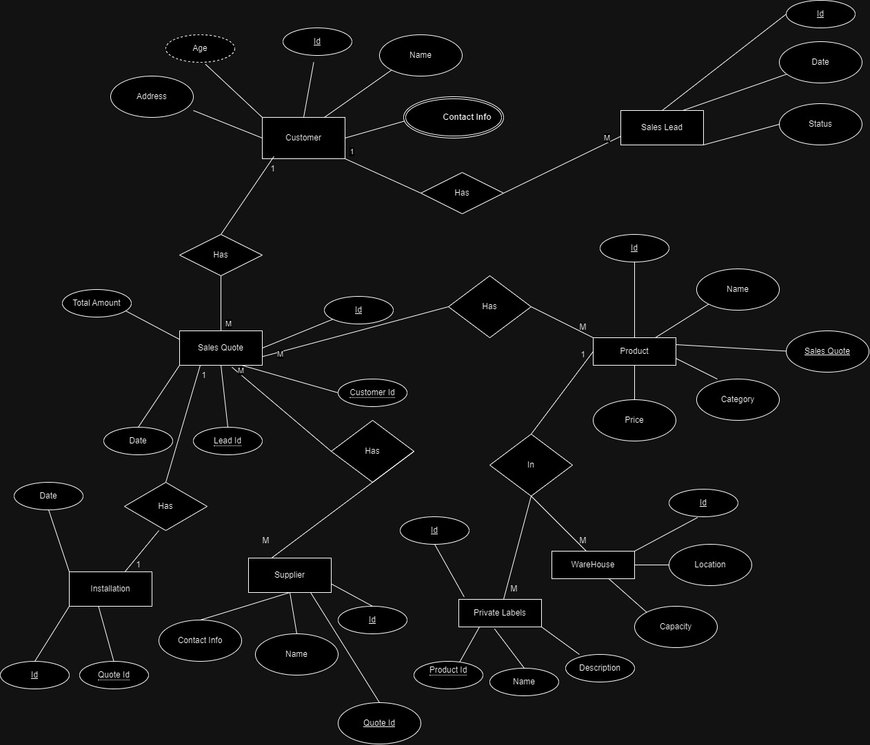

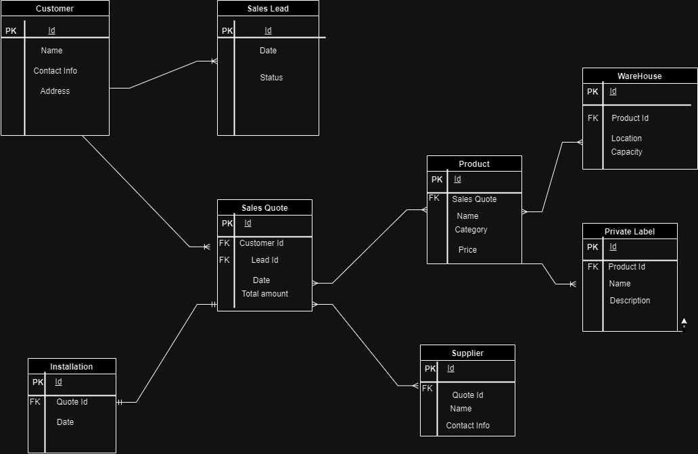

# **4. Database Design**

# The core of the data set plan lies in characterizing the tables, their qualities, information types, and requirements. This segment will dig into the particular plan of each table in the proposed data set. Items Table: This table will store data about the items Colourz sells. The qualities might incorporate Product ID (a special identifier), ProductName, Depiction, Value, Quantity In Stock, and Category ID (an unfamiliar key referring to the Classes table). Clients Table: This table will contain information connected with Colourz's clients. The properties might incorporate Customer ID (a one of a kind identifier), FirstName, Last Name, Email, Telephone, and Address. Orders Table: This table will store data about the orders set by clients. The properties might incorporate Order ID (an interesting identifier), Customer ID (an unfamiliar key referring to the Clients table), and Order Date. Order Items Table: This table will store the subtleties of every thing in a request. The qualities might incorporate Order Item ID (an extraordinary identifier), Order ID (an unfamiliar key referring to the Orders table), Product ID (an unfamiliar key referring to the Items table), and Amount. Providers Table: This table will contain information about Colourz's providers. The characteristics might incorporate Supplier ID (an exceptional identifier), Supplier Name, Contact Name, Email, and Telephone. Characterizing the suitable information types and imperatives for each trait guarantees information precision and consistency. For example, the Product Price property ought to have an information sort of decimal to store cash esteems precisely.

# **5. Normalization**

# Normalization is a basic cycle to dispose of overt repetitiveness and oddities in a data set. It includes sorting out information into independent tables to limit information duplication and further develop information respectability. The standardization cycle adheres to explicit guidelines or typical structures, like First Ordinary Structure (1NF), Second Ordinary Structure (2NF), and Third Typical Structure (3NF). First Ordinary Structure (1NF): Guarantees that each quality contains just nuclear (unified) values, and there are no rehashing gatherings. Second Typical Structure (2NF): Guarantees that the table is in 1NF and all non-key credits are completely subject to the whole essential key. Third Typical Structure (3NF): Guarantees that the table is in 2NF and all non-key credits are autonomous of one another. By applying standardization, the data set turns out to be more proficient, and information oddities, for example, information update peculiarities, are limited. The cycle additionally upgrades information uprightness and guarantees that information is put away in the most suitable way.

# **6. Interface Design**

For seamless communication with the database system, an intuitive and user-friendly interface is necessary. The database system for Colourz will be interface-designed in this part. The interface must make it simple to enter, retrieve, and manipulate data. The design will contain mockups and layouts for several screens, including those for managing products, customers, orders, and suppliers. Each screen should have a logical layout, with labels and input boxes that are obvious. It should be easy to find the buttons for adding, modifying, and removing records. Employees of Colourz who will use the database will gain from a well-designed interface that simplifies their work and lowers the possibility of mistakes.

.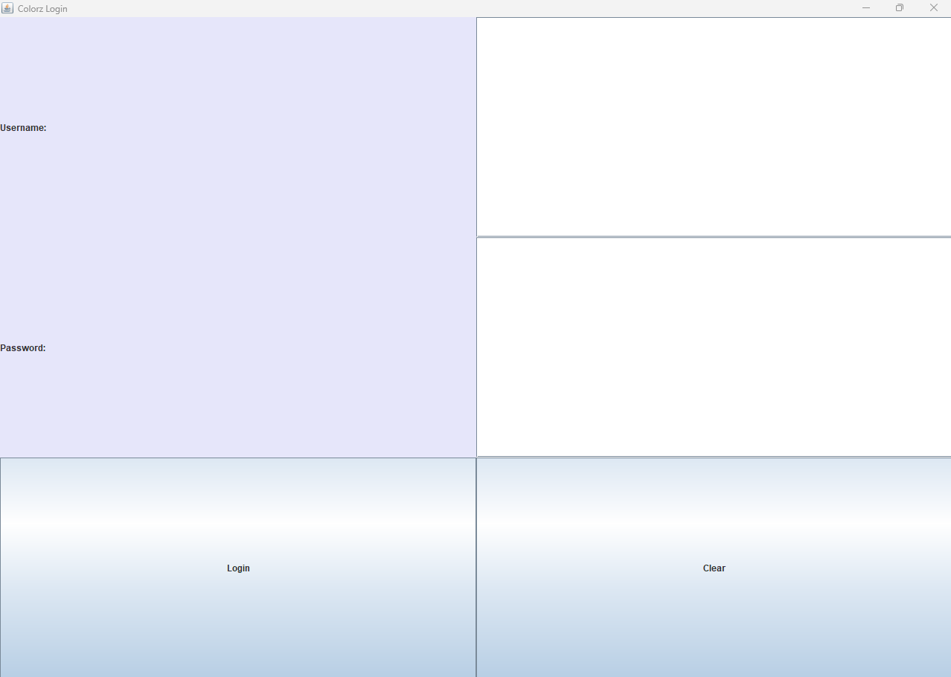

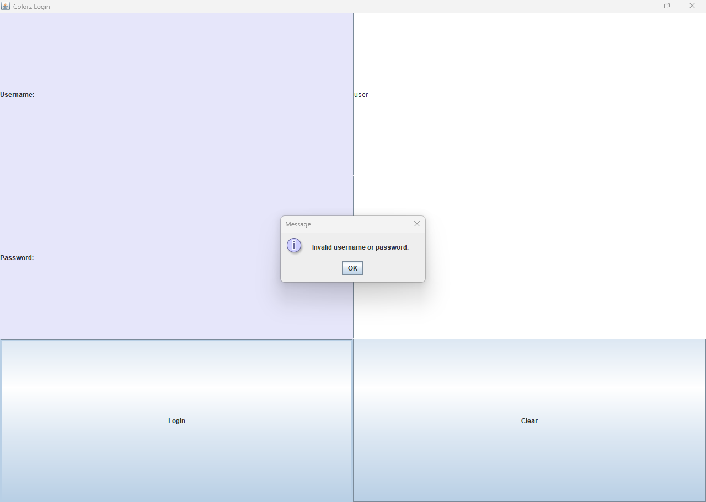

After I login this can see the dashboard

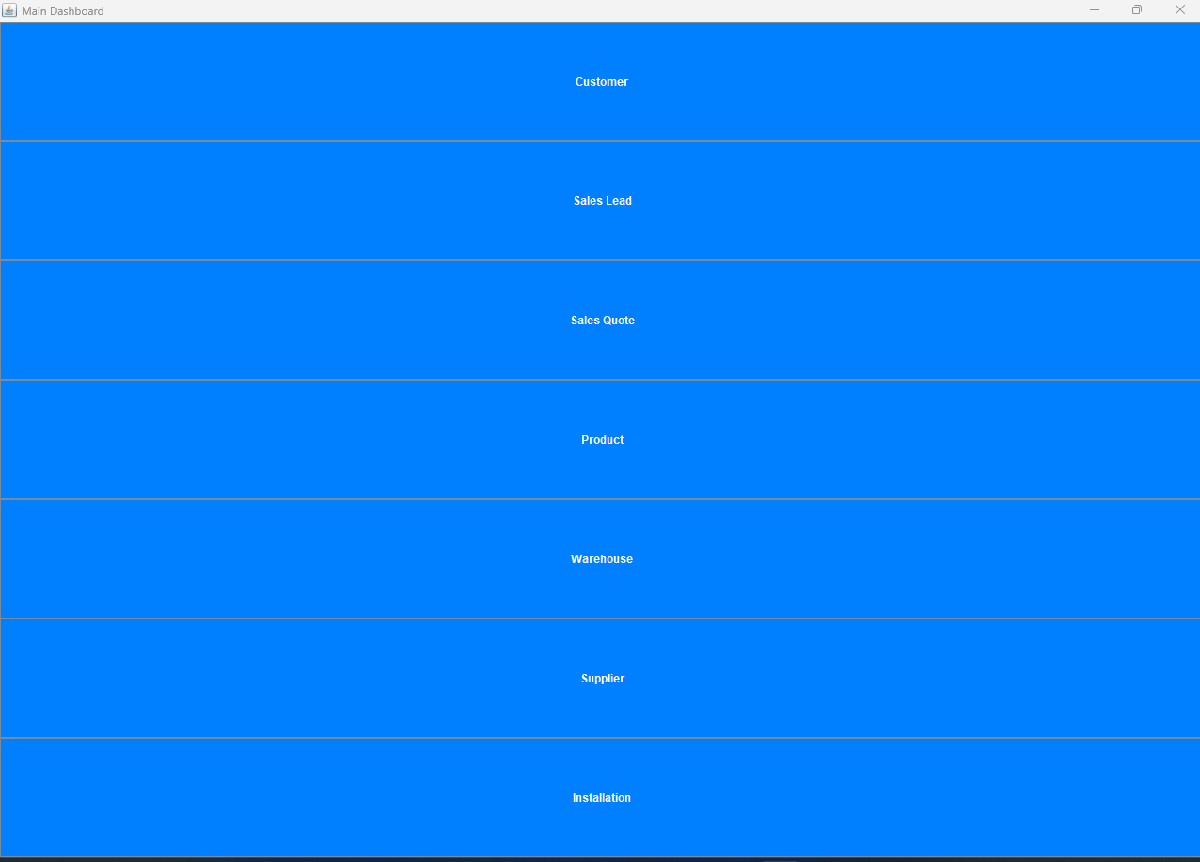

**Customer**

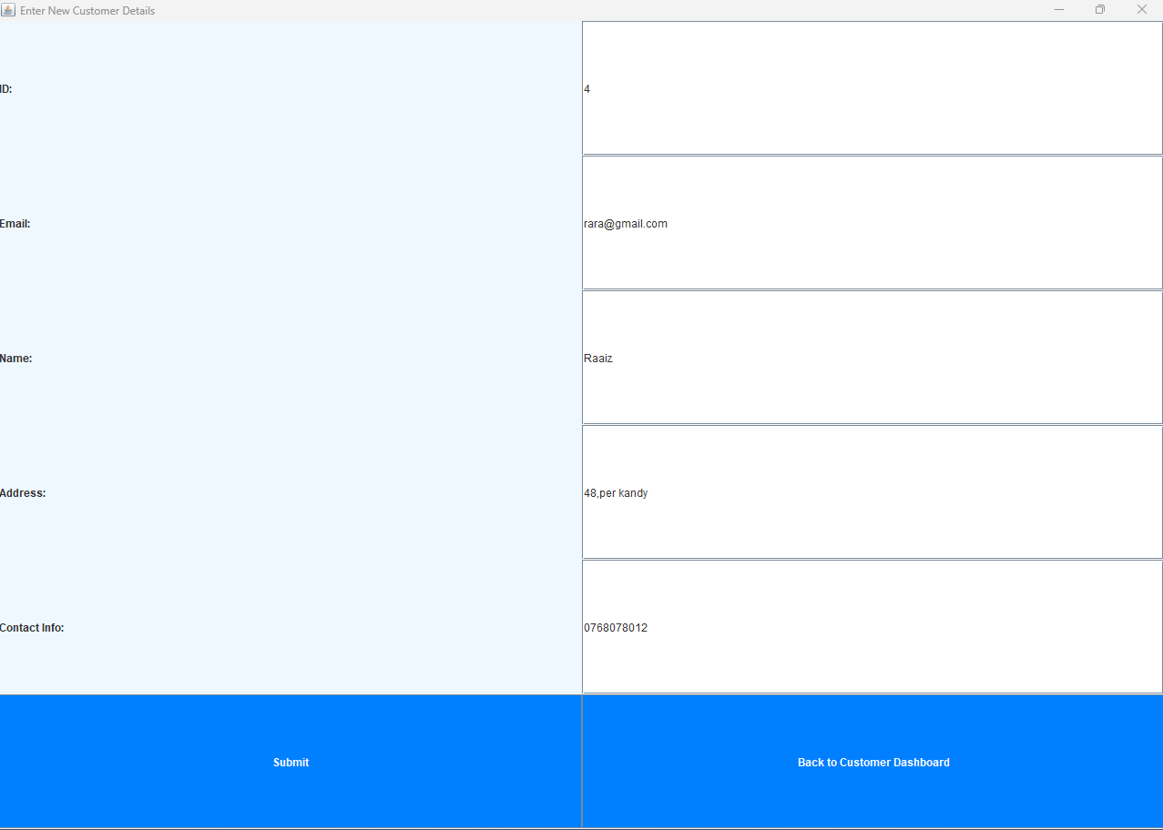

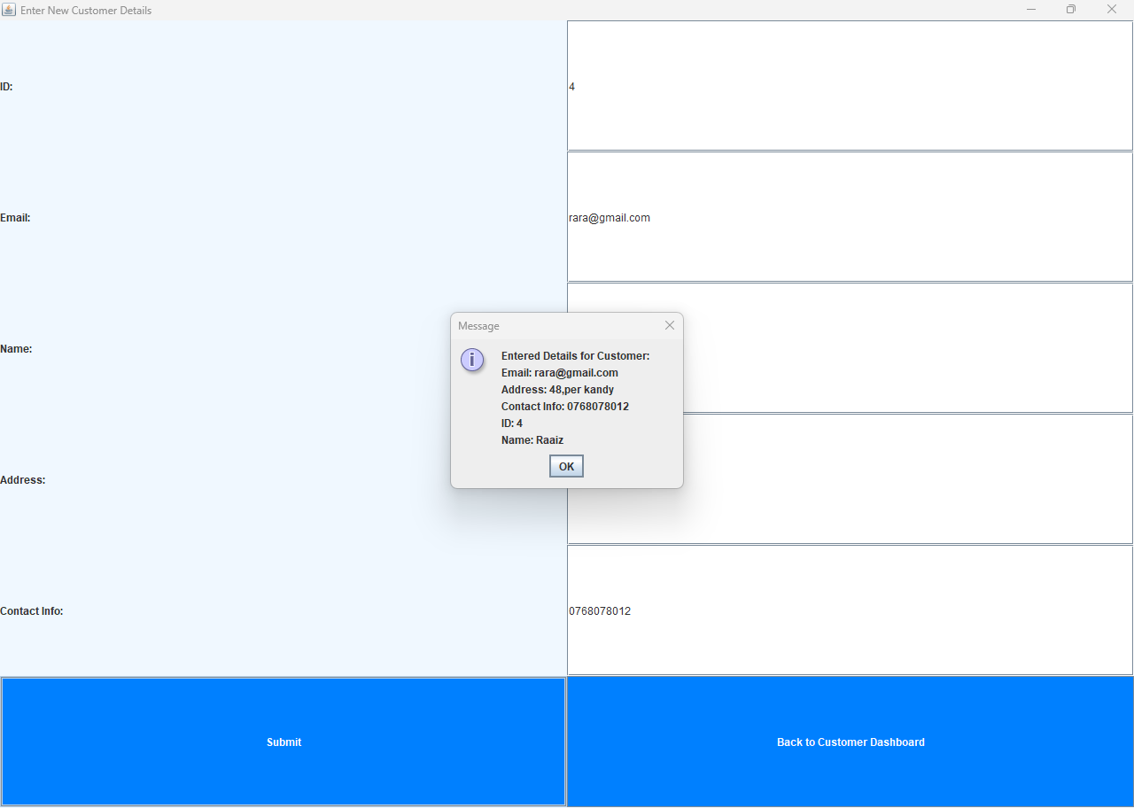

**Sales Lead**

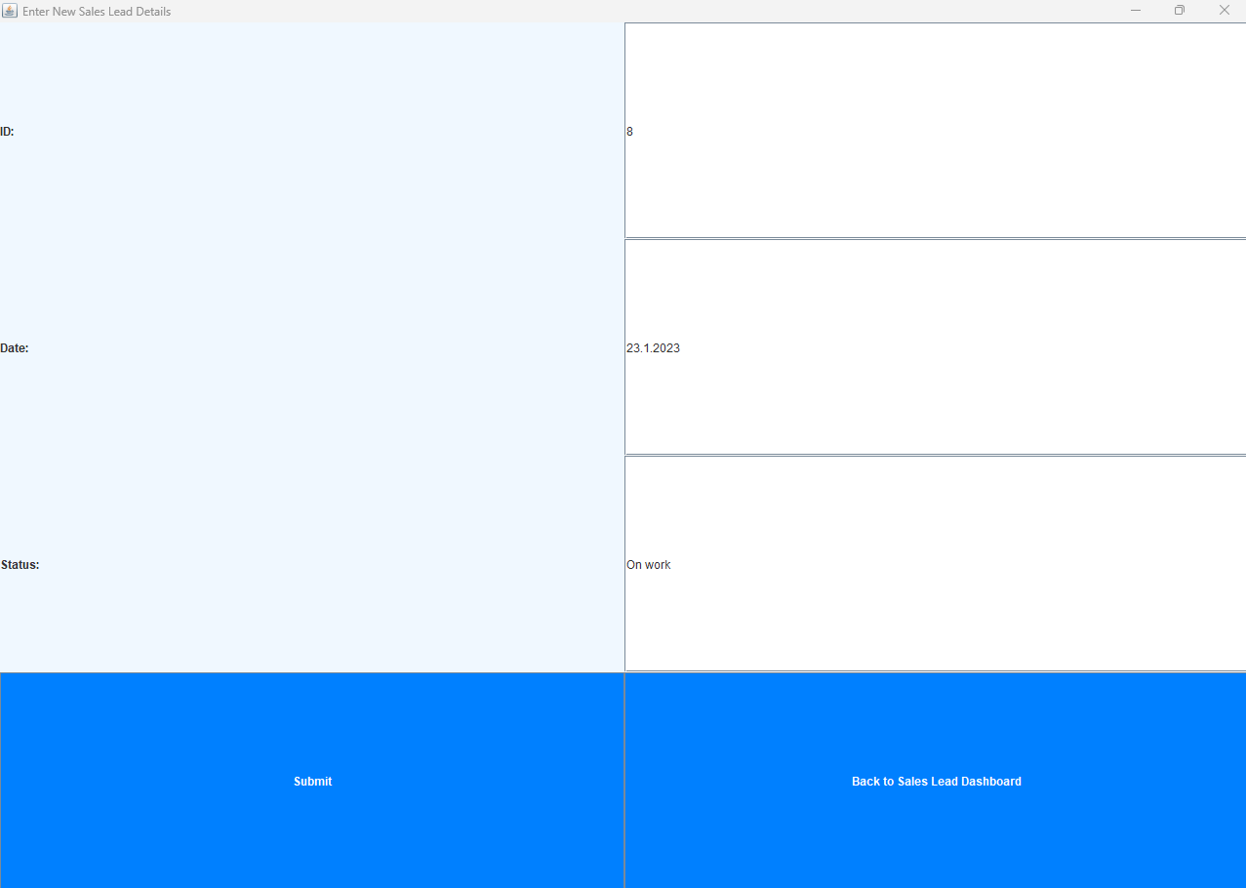

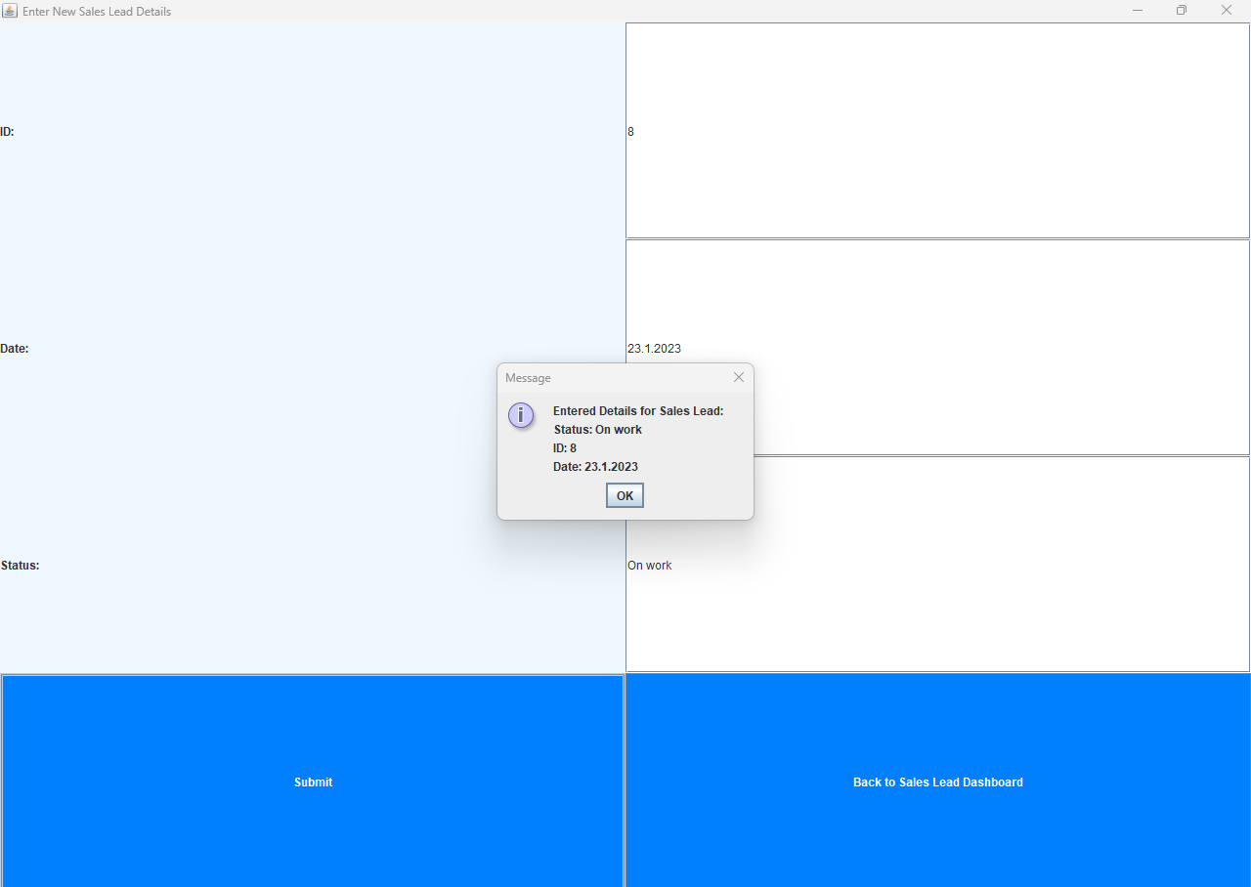

**Sales Quote**

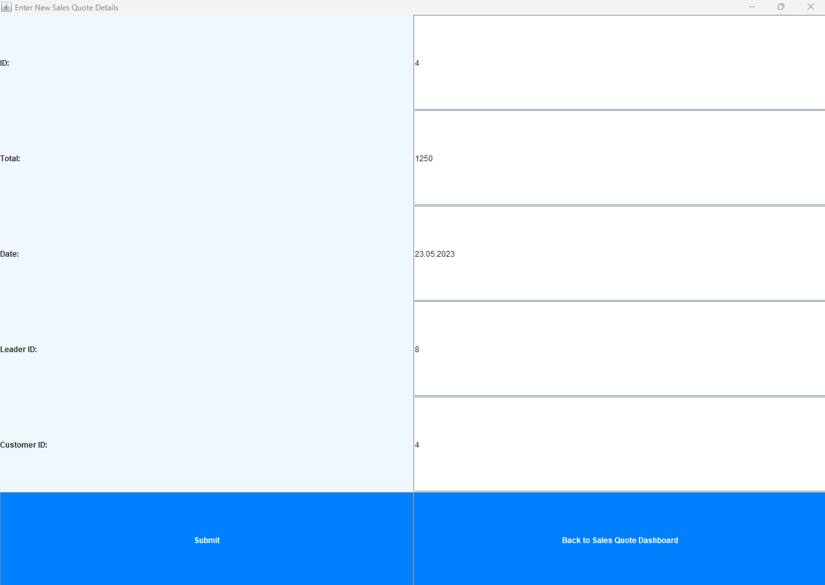

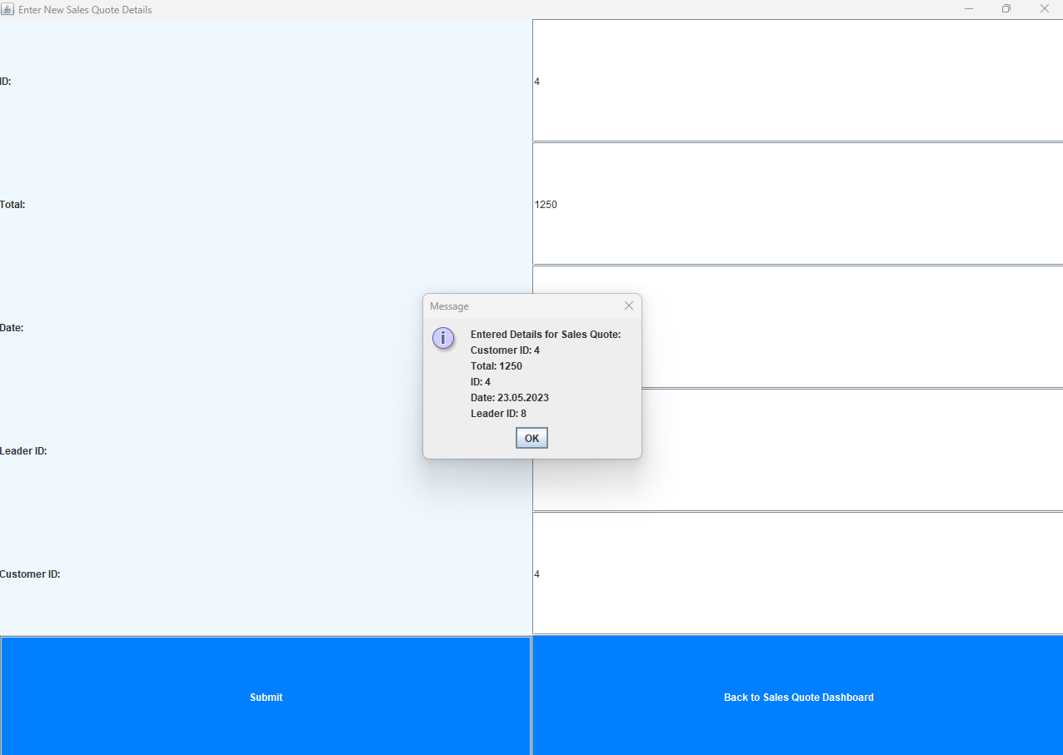

**Product**

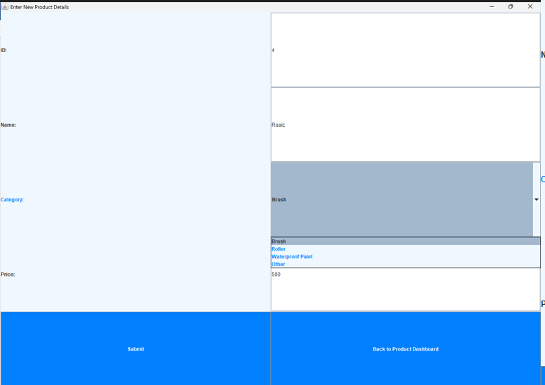

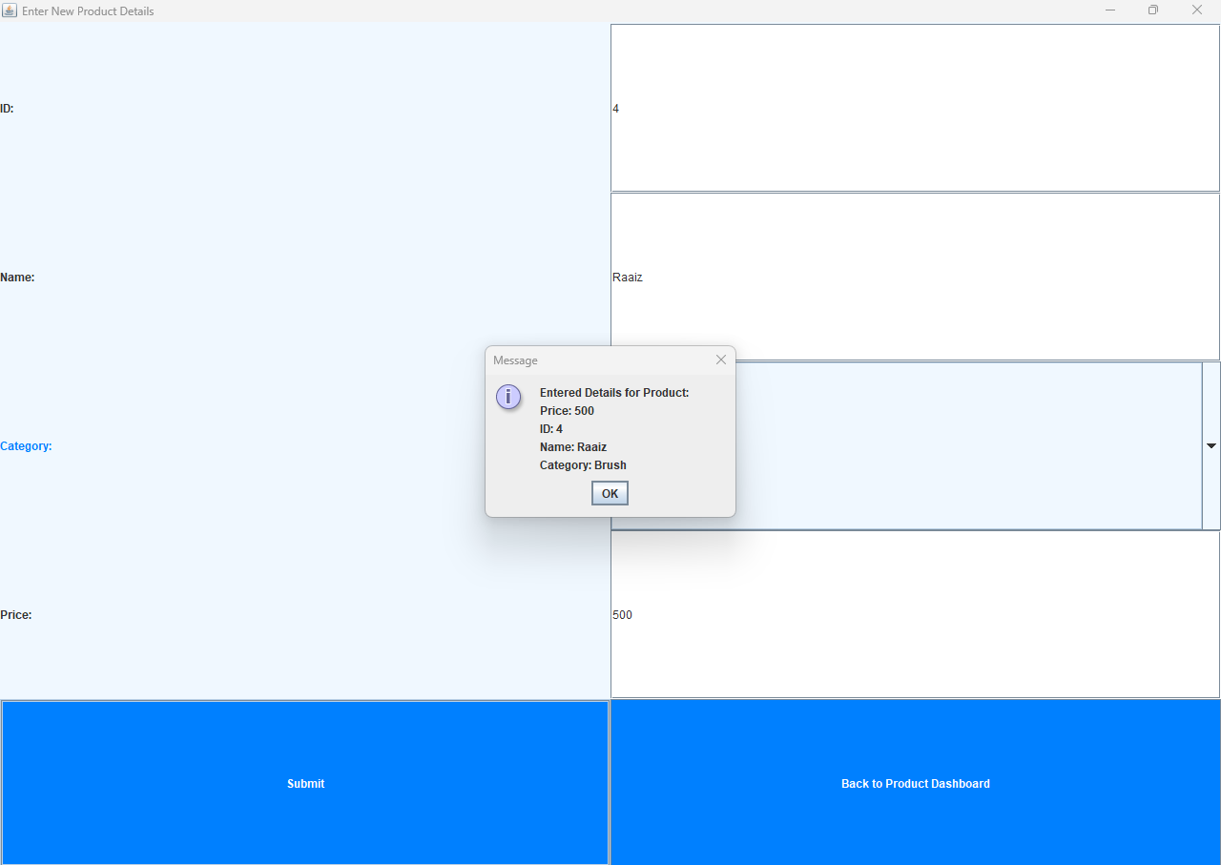

**Warehouse**

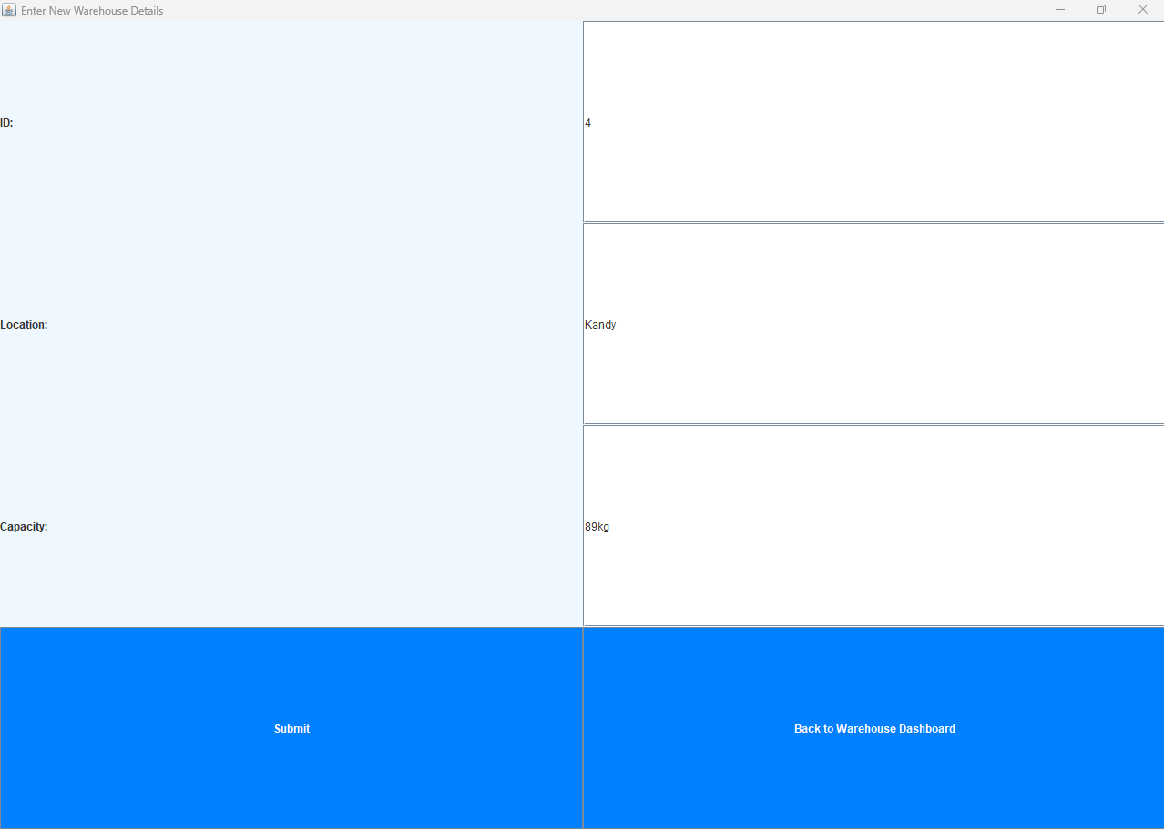

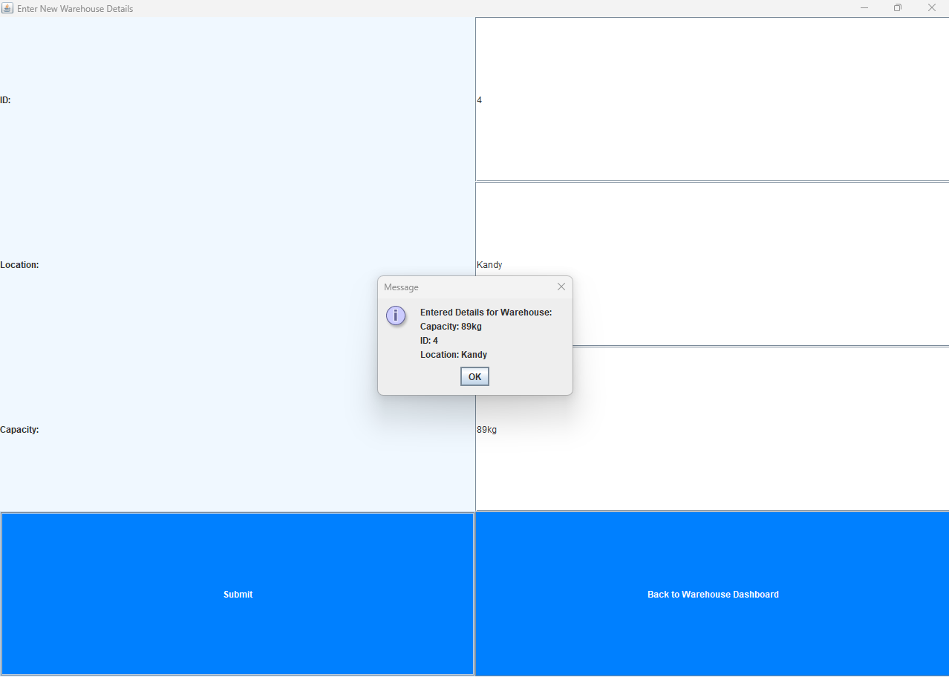

**Installation**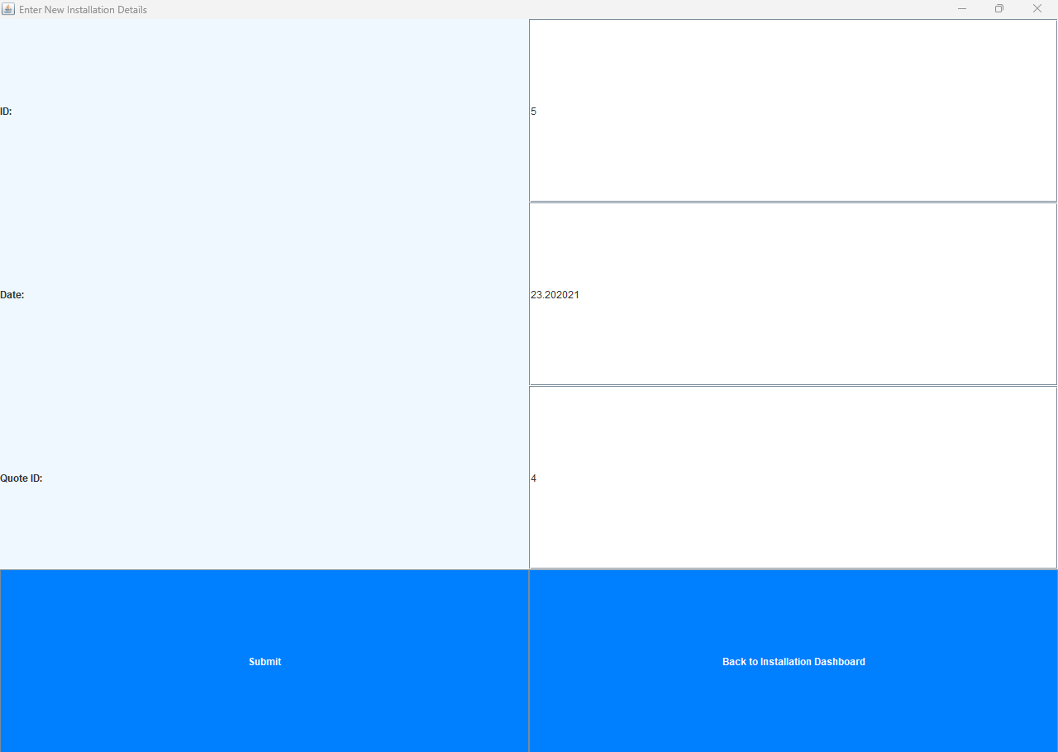

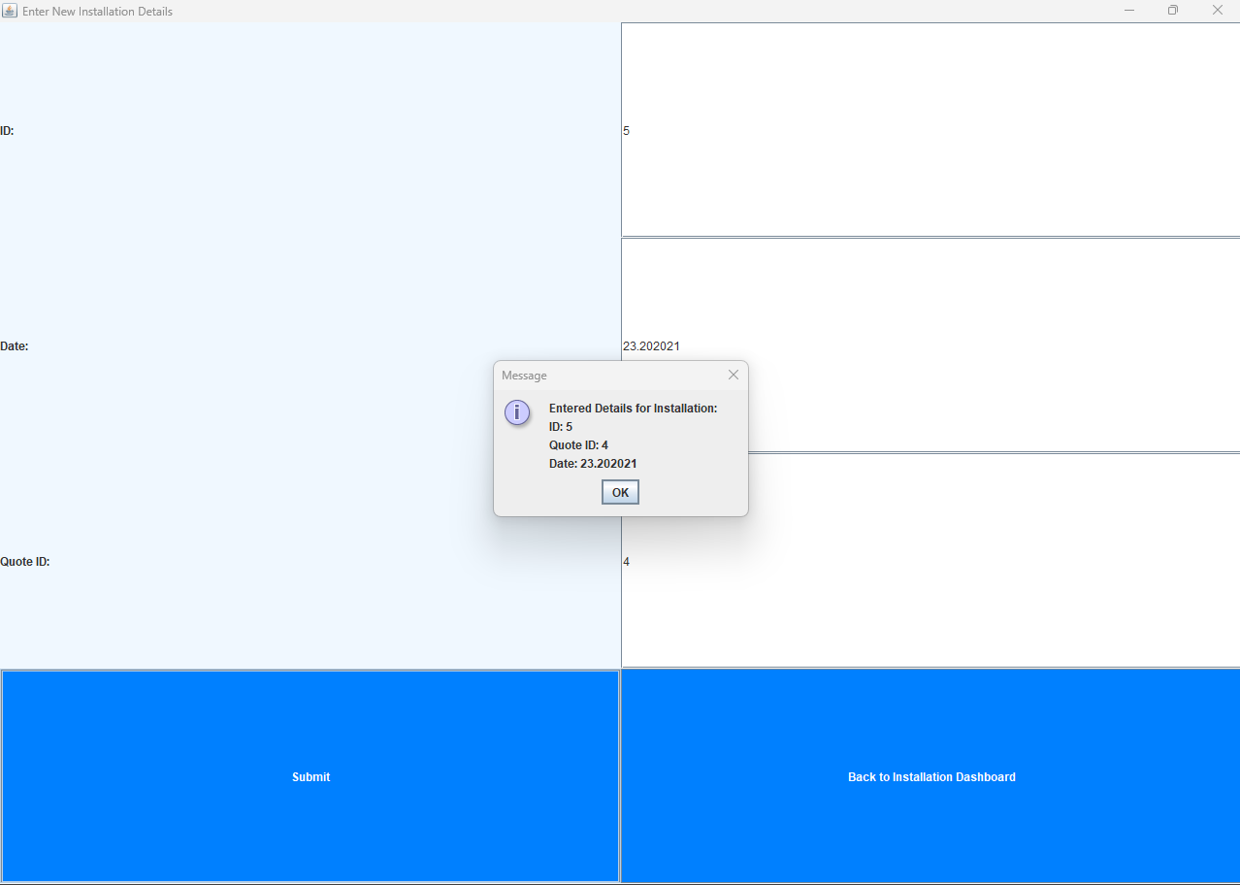

Clicked the in stallation u can see interface like all of the interfaces inside like the same

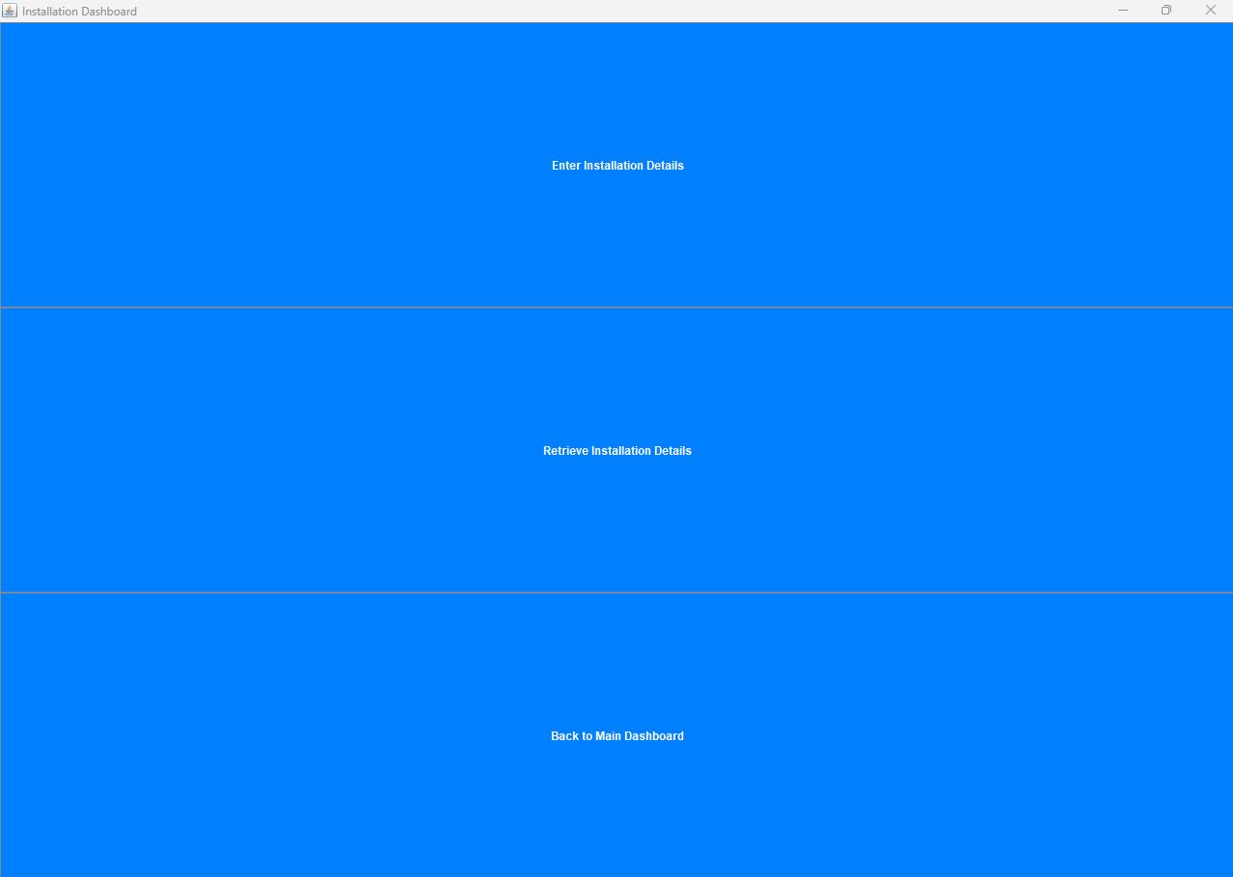

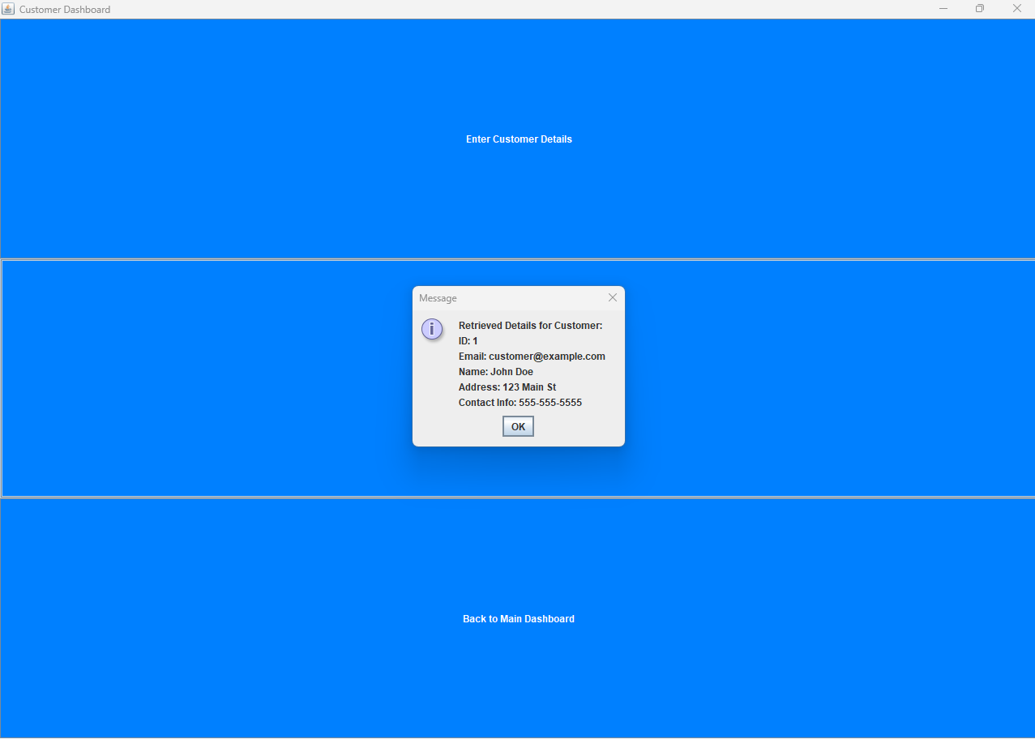

Retrieved Data

# **7. Data Validation**

Data validation is crucial to ensure that only valid and relevant data is stored in the database. Proper data validation prevents erroneous data from being entered and enhances data accuracy and consistency. There are various techniques for data validation, such as range checks, format checks, and referential integrity.

Range Checks: Ensure that data falls within specified ranges. For example, the QuantityInStock attribute should not accept negative values.

Format Checks: Ensure that data matches a specified format. For instance, the Email attribute should be validated to ensure it contains a valid email address format.

Referential Integrity: Enforce relationships between tables to maintain data consistency. For example, the foreign key relationship between the Orders and Customers tables ensures that each order is associated with a valid customer.

Data validation rules can be implemented at the application level or at the database level through constraints and triggers. Proper data validation enhances the reliability of the database system and reduces the chances of data-related errors.

# **8. SQL Queries**

SQL (Structured Query Language) is the standard language for interacting with relational databases. SQL queries enable data retrieval, manipulation, and analysis. In this section, we will provide a set of SQL queries tailored to Colourz's requirements.

Example SQL queries may included in the video also:

Retrieve all products in a specific category: This query will fetch all products that belong to a particular category.

Find customers who have placed orders in a particular month: This query will identify customers who have placed orders during a specific month.

Get the total value of orders for each customer: This query will calculate the total value of orders placed by each customer.

List suppliers and the products they supply: This query will display a list of suppliers and the products they provide.

# Update product information based on ProductID: Using this query, you may change the pricing and quantity of a product, among other information.

# Determine the total number of units of a product sold: This query will determine the total number of units of a certain product sold throughout all orders.

# In order to assist data analysis and reporting and to extract useful information from the database, SQL queries are essential.

# **9. Evaluation and Performance**

In the wake of planning the data set framework, assessing its exhibition and viability in gathering Colourz's requirements is fundamental. This part will evaluate different parts of the information base framework, for example, Information

Recovery Execution: Dissecting the productivity of questions and guaranteeing that they execute rapidly, even with huge informational collections.

Information Control Execution: Surveying the speed of information inclusion, update, and cancellation tasks. Scalability: Assessing the framework's capacity to deal with expanding information volumes and client loads.

Client Experience: Gathering criticism from Colourz's representatives to comprehend their involvement in the data set framework's connection point and ease of use.

Information Uprightness: Confirming that information approvals and imperatives are viable in keeping up with information honesty. In light of the assessment, proposals for expected upgrades or improvements might be proposed to upgrade the data set framework's general execution.

# **10. Security and Data Privacy**

# Any database system must prioritize data security and privacy, especially when handling sensitive client data. The security procedures put in place to protect Colourz's data will be described in this section. Authentication: Putting in place user authentication procedures to make certain that only permitted users may access the database. Establishing access controls to limit user rights and stop unauthorized access to sensitive information is known as authorization.

# Encryption: Using data encryption methods to safeguard data both during data transmission and while it is being kept in a database. Using audit trails, database activity may be tracked and watched for possible security holes.

# Data masking: Using data masking techniques to prevent unauthorized reading of sensitive data. By implementing strong security measures, Colourz can increase client confidence and make sure that data protection laws are being followed

# **11. Backup and Recovery**

Any organization's data is a precious asset, and losing that data may have serious repercussions. Data continuity and business resilience require a strong backup and recovery plan. This section will go through the backup techniques used to produce trustworthy data backups and the data restoration processes used in the event of system breakdowns or other emergencies.

Regular Backups: Implementing periodic database backups to guarantee the availability of copies of the most recent data.

Offsite Storage: Protecting against natural calamities by storing backups in safe offsite locations. Point-in-Time Recovery: Enabling point-in-time recovery allows you to recover from unintentional data changes or mistakes by restoring the database to a defined time. Creating a thorough disaster recovery strategy to address significant system failures and data loss

A reliable backup and recovery strategy minimize downtime and data loss, enabling Colourz to maintain business continuity in the face of unexpected events.

**1.Safety efforts: Subtleties on information assurance, encryption, and measures to forestall unapproved access.**

Security is a main concern, and our data set framework consolidates severe measures to safeguard delicate information. We utilize job based admittance control (RBAC) to just limit admittance to approved faculty. Furthermore, information encryption procedures, like SSL/TLS, are utilized to get information transmission among clients and the data set server. Information very still is likewise scrambled to forestall unapproved access if there should arise an occurrence of actual breaks.

In outline, this report gives a far reaching outline of our data set framework, including its construction, key highlights, ordering methodology, t he job of put away systems and triggers, reinforcement and recuperation strategies, and safety efforts. The security measures an organization employs to safeguard sensitive data are discussed in the passage provided. The most important points are as follows:

Security issues: The passage begins by emphasizing the firm commitment of the organization to security. It acknowledges the importance of protecting sensitive data.

Access control based on roles (RBAC): The association utilizes Job-Based Admittance Control (RBAC) as a safety effort. RBAC is a technique for overseeing client admittance to frameworks or information in view of their jobs inside the association. To put it more succinctly, it ensures that individuals are only granted access to the functions and data required for their particular job roles. This helps prevent data breaches and unauthorized access.

Encryption of Data: The entry makes reference to the utilization of information encryption methods, explicitly SSL/TLS (Secure Attachments Layer/Transport Layer Security). When it comes to securing the transmission of data over networks like the internet, SSL/TLS protocols are frequently used. They make certain that encrypted data is exchanged between users and the database server, making it difficult for malicious actors to intercept and read the data while it is in transit. When it comes to securing data as it moves between the user and the database, this encryption is absolutely necessary.

Restful encryption of data: The company encrypts data both while it is in motion and while it is in transit. Information very still alludes to information that is put away on actual gadgets (e.g., hard drives, strong state drives) inside the data set server. The company ensures that even in the event of a physical breach or unauthorized access to the database server, the data will remain unreadable without the appropriate decryption keys by encrypting data at rest.

In conclusion, the following measures highlight the organization's dedication to data security in this passage: To restrict access to authorized personnel, Role-Based Access Control (RBAC) is used.

Encryption methods like SSL/TLS to safeguard information during transmission. Data encryption is at rest to ward off unauthorized access in the event of server compromise or physical breaches. These safety efforts on the whole add to an extensive way to deal with information assurance in the association's data set framework, assisting with protecting delicate data and relieving potential security gambles.

# **12. Conclusion**

In conclusion, this comprehensive design for a relational database system addresses Colourz's requirements for product inventory management, customer management, order management, and supplier management. The design encompasses the table structures, normalization, interface design, data validation, SQL queries, security measures, and backup strategies. By implementing this design, Colourz can streamline its operations, enhance data integrity, and make informed data-driven decisions.

In today's data-centric business environment, a well-designed and efficiently managed database system is a critical asset for any company, including Colourz. With this comprehensive design, Colourz can leverage the power of data to drive business growth and customer satisfaction.

# 

# **Activity 02**

## **User Documentation**

### **1.Graphical User interface**

In this part, clients will track down bit by bit direction on getting to the framework and exploring its connection point successfully. These methods plan to limit the expectation to learn and adapt and guarantee a smooth onboarding process for new clients. Key parts include:

Framework Access: Clients will get clear directions on the most proficient method to get to the framework, including login accreditations and passageways (e.g., web-based interface, portable application).

Fundamental Route: Clients will figure out how to explore the framework's connection point, including the format of menus, dashboards, and key capabilities like pursuit and channels.

This section explains how users can access the system and how to use its interface in the most efficient way. The goal of these steps is to make it easier for new users, especially, to get used to the system and have a smooth onboarding process. The key components are described as follows:

System Access:

Simple Directions: The system's access procedure will be explained to users in great detail and clarity. This includes the location of their usernames and passwords, as well as other login information.

Points of Entry: The various access points that are available to users will be explained to them. This could include a mobile application for use on smartphones or tablets as well as a web-based interface, which can be accessed on a computer through a web browser. Depending on their requirements and preferences, users will be instructed on which access point to use.

How to Get Around

Summary of the Interface: Clients will figure out how to explore the framework's point of interaction. This incorporates figuring out the design of menus, dashboards, and other key components of the UI.

Menu Management: Menus will be used to show users how to use various features and functions. Depending on the design of the system, this might involve drop-down menus, sidebars, or top navigation bars.

Dashboards: The system's dashboards, which frequently offer quick access to essential tools or a summary of important information, will be shown to users. They will be taught how to use these dashboards to keep track of and manage their system activities.

Filters and Search: How to use the system's search features and filters to find specific records or information will be explained to users. This is essential for finding and working with data effectively.

The primary goal of these instructions is to make sure that users, especially newcomers, can quickly start using the system's core features, understand its layout and structure, and easily access it. The company wants to make the onboarding process as easy as possible and reduce the learning curve by providing clear and concise instructions. This will help users use the system more productively and effectively.

**1.Login**

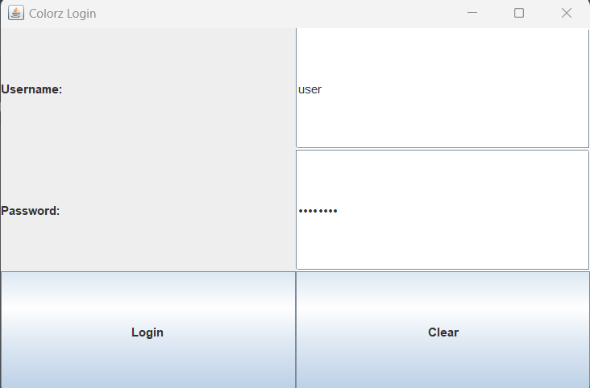

This is the interface created by me need to login via this for the my application add username as user add password for the password section after that enter the login. In the clear button we can clear the login button. If you forgot the password send us mail for this [rararra@gmail.com](mailto:rararra@gmail.com) this email forgot Color’s password like that.

**2.Error Password**

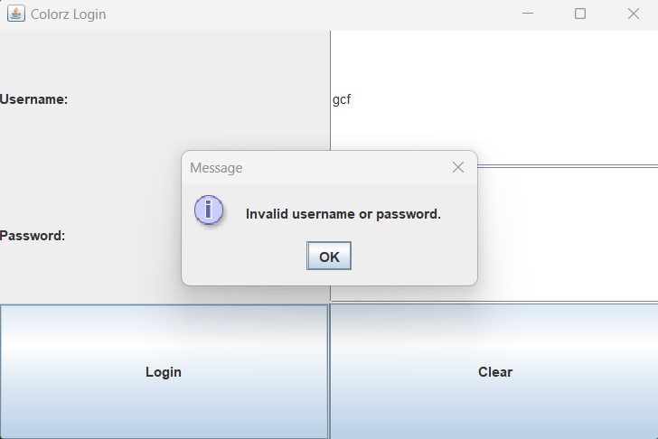

**3.Dashboard**

In this dashboard user can see the details of all our system. This was the user manual made by us.

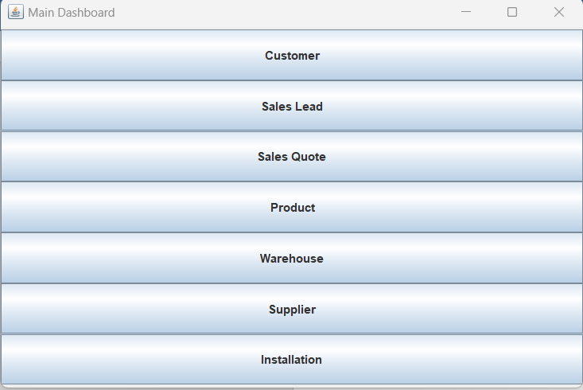

**4.Click Inside the Dashboard**

In this I will show how to enter one. I will go in to customer jus like that all we need to go same procedure for the all in here.

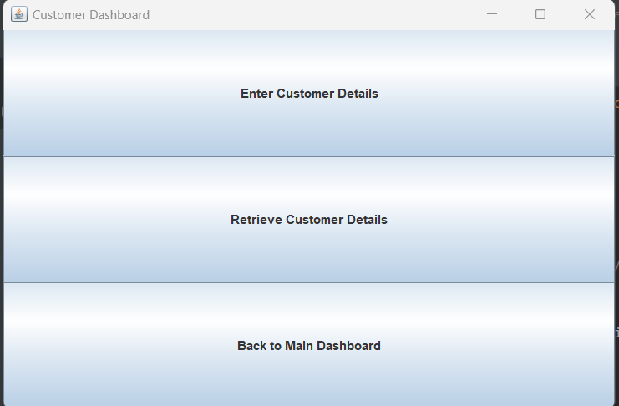

Now I am going to click enter customer details

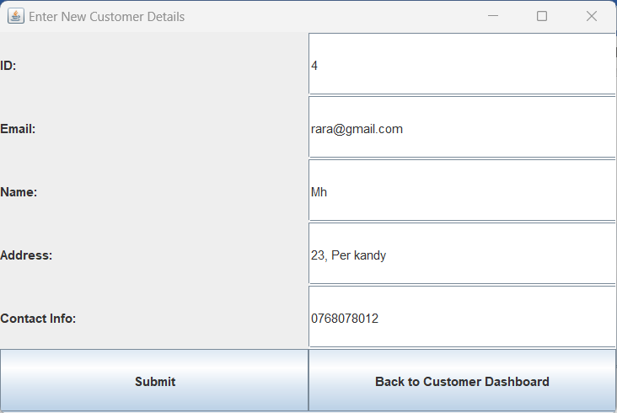

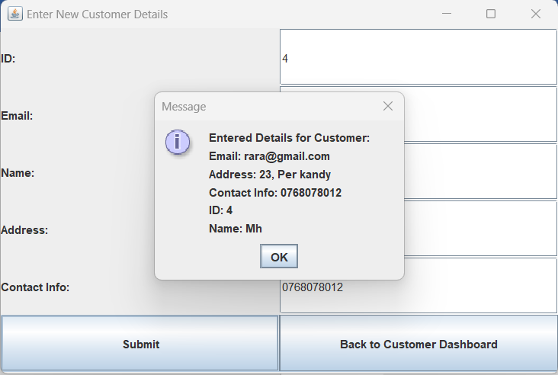

**5.Retrieve Details**

I submitted the details so based on these we need to gen the entered details for a backup. So we used the retrieve button

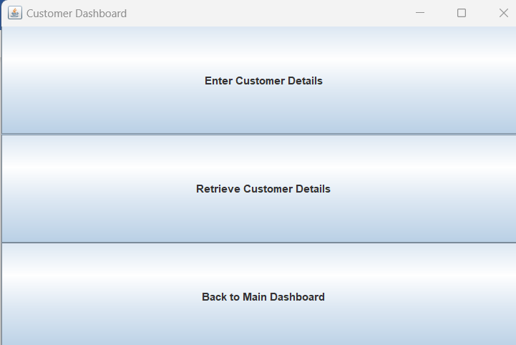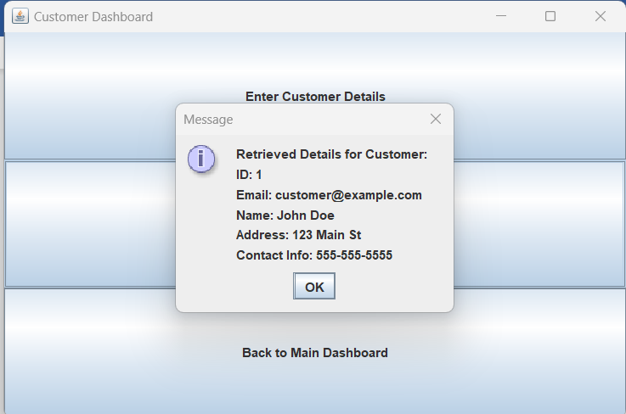

**6.Back To Dashboard**



**I clicked the back to dashboard and I got this interface**

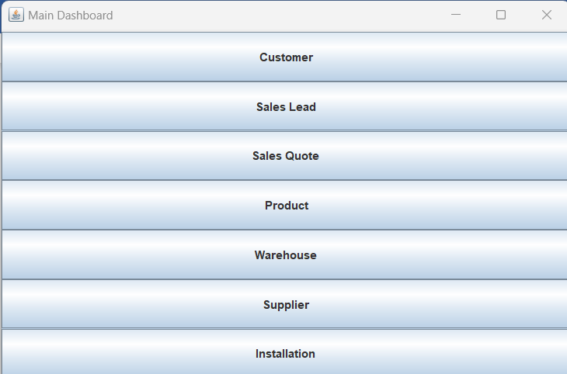

**Main Point**

Directions on ordinary activities like overseeing potential customers, stock, and so forth.

This segment offers point by point directions on performing fundamental errands inside the framework. It engages clients to use the framework's functionalities to their maximum capacity. Key errands covered may include:

Overseeing Prospective customers: Clients will be directed through the method involved with adding, refreshing, and following prospective customers, including how to relegate prompts colleagues.

Stock Administration: Bit by bit guidelines on adding, refreshing, and following stock things, as well as producing investigates stock levels.

Information Examination: Clients will figure out how to get to and decipher information reports and investigation, helping with informed navigation.

Correspondence: Directions on utilizing the framework's specialized devices, for example, informing and notice highlights, to upgrade cooperation.

For users to carry out essential system tasks, this section provides in-depth instructions. Its goal is to give users the tools they need to get the most out of the system's features and capabilities. This section may cover the most important tasks like:

### **2. Investigating: Normal issues and their goals.**

In this segment, clients will find answers for normal issues they might experience while utilizing the framework. It fills in as an investigating manual for address and resolve issues quickly. Instances of normal issues and their goals might include:

Login Issues: Direction on what to do on the off chance that a client experiences login issues, for example, secret word reset guidelines.

Information Section Blunders: Moves toward right information passage mistakes or errors in the framework.

Execution Lull: Suggestions for further developing framework execution assuming it becomes slow.

### **3. Backup and Recovery Procedures:**

Reinforcement Methods: Information is routinely upheld utilizing a blend of full reinforcements and steady reinforcements. Full reinforcements are performed week after week, while steady reinforcements are led every day. Full reinforcements catch the whole data set, while steady reinforcements catch changes made since the last reinforcement.

Recuperation Systems: To reestablish information from reinforcements, the reinforcement documents are recovered from on-location and off-site capacity areas. The information is then remade by applying the full reinforcement and resulting gradual reinforcements in sequential requests. Standard testing of the recuperation interaction guarantees its unwavering quality.

Capacity Areas: Reinforcement information is put away both on-location and off-site. On-location reinforcements are kept in a protected server room with limited admittance. Off-site reinforcements are put away in a far-off server farm to protect against actual debacles.

.**4.Maintenance Schedule:**

Programming Updates: Programming updates and fixes are applied during planned upkeep windows, commonly during off-top hours to limit personal time.

Information base Streamlining: Data set improvement schedules, including record upkeep, inquiry enhancement, and data set defragmentation, are booked consistently to guarantee ideal execution.

Framework Wellbeing Checks: Customary wellbeing checks are performed every day to screen framework parts, recognize expected issues, and make proactive moves to immediately address them. This incorporates checking computer chip use, memory usage, and server uptime.

In conclusion of these we can handle the software type like these via user manual of these and we can identify what we need to do and what we can access such like that.

## **Technical Documentation**

### **1.Beginning Guide: Getting to the Java-Based Data set Framework**

Welcome to our Java-based data set framework! This guide will assist you with getting everything rolling with signing in and getting to the framework. We focus on security, so we'll likewise clarify how for change your secret phrase.

**Signing In:**

Open the Java Application: To get to the data set framework, send off the Java application introduced on your PC.

Enter Your Accreditations: You'll be provoked to enter your username and introductory secret phrase. These accreditations will be given by your framework head.

Click 'Login': Subsequent to entering your accreditations, click the 'Login' button.

**Changing Your Secret key:**

Secret phrase security is critical. Follow these moves toward changing your secret phrase:

Log In: Utilize your underlying qualifications to sign in to the framework.

Access 'Change Secret key': In the principal menu, find and select the 'Change Secret key' choice.

Enter Current and New Secret key: You'll be approached to enter your ongoing secret key and afterward your new secret phrase two times for affirmation.

Click 'Change': In the wake of entering the necessary passwords, click the 'Change' button to refresh your secret phrase.

**Secret word Security Tips:**

Utilize a mix of upper and lower-case letters, numbers, and extraordinary characters in your secret key.

Stay away from effectively guessable passwords like "password123" or familiar words.

Try not to impart your secret phrase to anybody.

Change your secret key routinely.

Keep in mind, your secret word is your key to get access, so keep it safe and follow these prescribed procedures.

That is all there is to it! You're presently prepared to begin utilizing our Java-based data set framework. Assuming you experience any issues or have questions, go ahead and out to our help group for help.

### **2. Flow Chart**

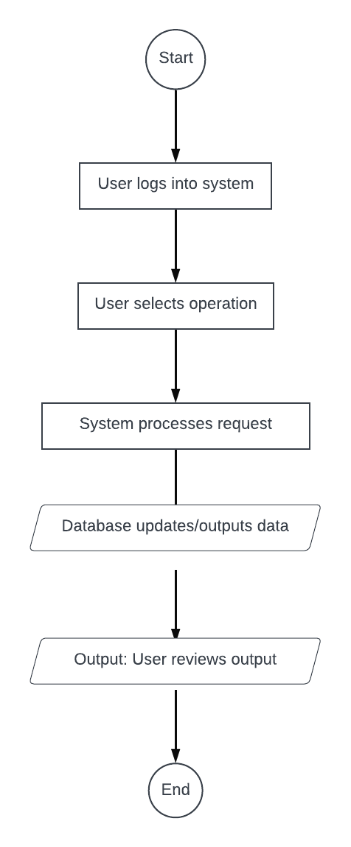

Flowcharts: Using Flowcharts to Show System Processes Flowcharts are powerful visual tools used to show system processes step by step. They show how decisions and activities move through a system in a clear and concise way. While like Information Stream Outlines (DFDs) in certain regards, flowcharts offer a more point-by-point portrayal of consecutive and equal cycles, making them an important resource in framework examination and plan.

Flowcharts' Elements:

Various symbols and shapes are used in flowcharts to represent various processes. Effectively conveying information is made possible by these parts:

Ovals: These indicate where a process begins and ends. At the point when you experience an oval in a flowchart, it commonly denotes the commencement or decision of a specific cycle or sub-process.

Rectangles: A process's activities or steps are represented by rectangles. They indicate actions or responsibilities that must be completed to advance the process.

Diamonds: Throughout the process, decision points are represented by diamonds. "Yes" or "No" or "True" or "False" are common choices at these decision points. The course that the process will take is determined by the results of these choices.

Arrows: The various shapes and symbols are connected by arrows, which indicate the order and direction of the actions or decisions. They show the reader how each step in the flowchart leads to the next.

Parallelograms: Parallelograms address info or result activities. They represent entry points for data or the process's presentation of results.

The Advantages of Flowcharts:

There are a number of advantages that make flowcharts useful in system analysis, process optimization, and training, among other areas:

Clear Interaction Portrayal: Flowcharts give a visual and effectively justifiable portrayal of complicated processes. They make it easier for people to understand how the system works by breaking down each step and decision point.

Preparing and Onboarding: When training new employees or integrating new members of a team, flowcharts are extremely helpful. They help newcomers quickly understand their roles and responsibilities by providing a step-by-step explanation of how processes work.

Identifying Obstacles A process's bottlenecks, inefficiencies, or weaknesses can be seen in flowcharts. Teams are able to identify areas that require enhancements or optimizations by visualizing the steps' order.

Documentation of the Process: Flowcharts are useful tools for documentation. They give an extremely durable record of a framework's cycles, making it more straightforward to impart, examine, and investigate issues over the long haul.

Support for Making Decisions: Flowcharts help in direction by showing the outcomes of various decisions inside a cycle. This guides in pursuing informed choices that line up with the ideal results.

Standardization: Standardizing procedures and ensuring operation consistency are made easier with flowcharts. By reporting processes outwardly, associations can lay out prescribed procedures and keep up with them across various groups or offices.

In conclusion, flowcharts are useful tools for visualizing and comprehending a system's sequential processes. They utilize a scope of shapes and images to address key components, for example, exercises, choice focuses, and information streams. Process representation clarity, assistance with training and onboarding, the identification of bottlenecks, and support for decision-making are all advantages of flowcharts. System analysis, process enhancement, and efficient company communication all depend on these visual representations.

Yes, let's go deeper into the theories, concepts, and types of flowcharts as well as their uses.

Flowchart Types:

Flowcharts can take a variety of forms, each of which is customized for a specific purpose. The following are some typical types of flowcharts:

Process Flowchart: This is the most widely recognized type, used to address the consecutive strides in a cycle. It shows how a process progresses through activities, decisions, and connectors.

Information Stream Chart (DFD): DFDs, like flowcharts, focus on how data moves through a system. They are particularly useful for representing the data movement between processes and entities in systems analysis.

Flowchart for Swimlane: Swimlane flowcharts are utilized to portray processes that include various divisions or people. Every division or entertainer is addressed in its own "swim lane," clarifying who is liable for each move toward the cycle.

Workflow Schematic: Work process graphs underscore the computerization of undertakings in a cycle. They demonstrate how data and tasks move through the system and frequently involve software or systems that handle tasks.

### **3. Managing Potential Clients:**

Adding Potential Clients: The procedure for adding new potential customers to the system will be explained to users. This requires entering pertinent information about potential leads, like contact information and the source of the lead.

Keeping prospective clients current: How to update existing records of prospective customers will be explained. Clients might have to change contact data, status, or other significant subtleties as the relationship with the lead develops.

Following Imminent Clients: Users will learn how to use the system to follow potential customers' progress through the sales or conversion pipeline. Lead generation, follow-up, and conversion may be included in this. They could likewise figure out how to dole out prompts colleagues for effective joint effort.

**Stock Administration:**

Adding Items to Inventory: How to add new items to the inventory will be explained to users in detail. In most cases, this entails entering information like the name, description, quantity, and price of the product.

Inventory Maintenance: How to update existing inventory items will be covered in the instructions. This could mean changing the details of the item, changing the price, or updating the quantity.

Monitoring Stock: Users will learn how to use the system to check on inventory items' availability. The instructions may also include setting up notifications for low stock and producing reports on stock levels.

**Analyses of Data:**

Accessing Analysis and Reports: The system's data reports and analysis tools will be demonstrated to users. Selecting predefined reports or creating custom reports to obtain useful insights may be necessary.

Data Interpretation: Users will learn how to interpret the data in reports and analyses by following instructions. They will learn how to use the information provided to make well-informed decisions.

Communication:

Utilizing Tech Tools: Instructions on how to use the system's technical communication tools will be provided to users. This may consist of notification features to keep you informed of upcoming events or tasks, as well as messaging features for team collaboration.

This section's primary objective is to equip users with the knowledge and abilities they need to carry out routine tasks within the system. The company ensures that users are able to effectively manage prospective customers, manage inventory, access and interpret data, and improve communication and collaboration by utilizing the system's features. This helps users get the most out of the system and work more efficiently

### **4.FAQs: Replies to potential client questions.**

To additional help clients, this segment gives replies to often sought clarification on some pressing issues (FAQs). These FAQs cover a scope of themes and are intended to address normal requests. Test FAQs might include:

The Frequently Asked Questions (FAQs) section of the client documentation report focuses on providing responses to common inquiries and concerns. The following is a description of this section:

FAQs: FAQs are ordinarily posed inquiries that clients might have while utilizing the framework. These inquiries frequently connect with different parts of framework use, investigating, and general data. The purpose of the frequently Asked Questions (FAQs) is to clarify frequently Asked Questions that users may have about the system.

Examples of frequently asked questions: A few examples of FAQs are provided in the passage to show the kinds of questions that users might ask. These inquiries cover a scope of themes and are expected to give pragmatic responses to help clients in like manner situations. Examples of questions are:

How to Change an Error Password: This FAQ tends to the methodology for resetting a secret key on the off chance that a client fails to remember it, guaranteeing that clients can recapture admittance to their records.

Tracking down Unambiguous Possible Clients: This FAQ makes sense of how for find a specific expected client inside the framework, assisting users with productively dealing with their leads.

Record Updates for Inventory: Best practices for maintaining accurate stock information are provided in this frequently asked questions (FAQ) regarding the frequency with which users should update their inventory records.

Empowerment of Users: The inclusion of frequently asked questions (FAQs) aims to provide users with quick and easy answers to common issues. Users are able to resolve their concerns more effectively by providing solutions to common issues, reducing the need for external support, and improving their overall experience with the system.

Extensive Aide: This client documentation report acts as an extensive manual for the framework. It goes over a variety of aspects of the system, including its purpose, fundamental usage, essential tasks, troubleshooting, and more, in addition to the FAQs. The purpose of this comprehensive guide is to guarantee that users will be able to meet their requirements using the system's capabilities in an effective and efficient manner.

In a nutshell, the client documentation report's FAQs section provides practical responses to frequently asked questions and concerns from users, empowering them to interact with the system. It is a useful resource for making the system's features more accessible to users and improving the user experience.

### **5. Data Flow Diagram (DFD)**

Reason: A DFD grandstands how information courses through a framework. It outwardly addresses the sources, objections, capacity components, information streams, and cycles in a framework.

Parts:

Processes: Addressed by circles or ovals, they change approaching information stream into active information.

Information Streams: Bolts that show the bearing of information development.

Information Stores: Address information resting or put away, frequently portrayed as two equal lines.

Substances: Outer components that connect with the framework, like clients or outside frameworks.

Benefits:

Helps in figuring out the usefulness of a framework.

Shows where information begins, where it's going, and the way in which it's changed.

Helpful in distinguishing framework shortcomings or weaknesses.

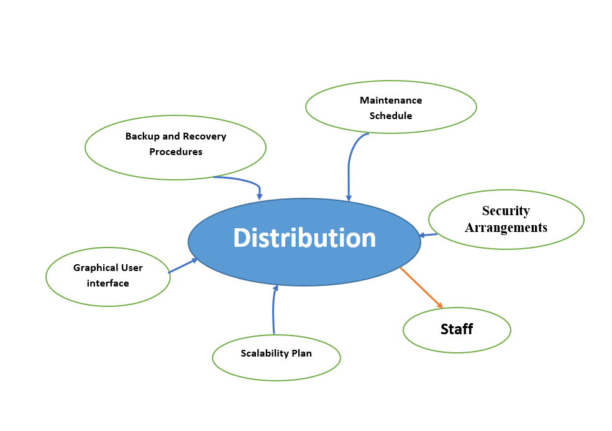

**6.Database Assessment and Suggestions**

You will evaluate Colorz's newly developed database system and offer suggestions for enhancement in this task. The system's usability, efficiency, and functionality should be the primary focus of this evaluation. The following is a breakdown of what this job entails:

**Analyses of databases:**

Evaluation of Functionality: Verify that the database system's functionality satisfies the stated requirements and goals. Verify that inventory management, customer management, sales tracking, and reporting are all functioning as intended.

Evaluation of Performance: Examine the framework's exhibition and effectiveness. Check for any slowdowns or bottlenecks that could reduce user productivity. Examine the processing and retrieval speed of the data.

Evaluation of Data Integrity: Verify the accuracy and integrity of the data in the database. Verify that data is stored and retrieved without error consistently. Guarantee that there are systems set up to forestall information duplication and information defilement.

Assessment of User Experience: Assess the database system's user interface. Consider whether the interfaces are intuitive for users with varying levels of computer literacy and how user-friendly they are. Collect user feedback to discover any usability issues.

Assessment of Security: Survey the safety efforts carried out in the data set framework. Examine the procedures for user authorization, data protection, and authentication. Make certain that sensitive data is adequately protected against unauthorized access. Now we are going to see percentage of analaysed feedback.

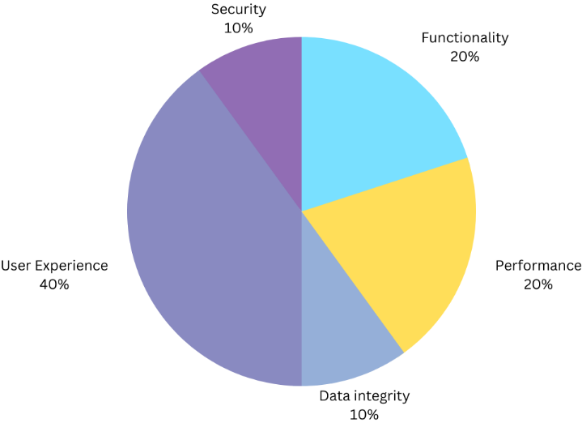

**Improvement Suggestions:**

Enhanced Performance: Identify and address any system performance issues. Optimizing database queries, indexing tables that are frequently accessed, and implementing caching mechanisms to increase responsiveness and speed may all fall under this category.

Documentation: Create extensive user and technical documentation for the database system. The specialized documentation ought to remember subtleties for data set construction, information stream outlines, and framework engineering. Step-by-step instructions for various user roles and computer literacy levels should be included in user documentation.

Training: If you want to make sure that Colorz employees are proficient in using the database system in an efficient manner, think about holding workshops or training sessions. User confidence can be raised and errors reduced through training.

Data Recovery and Backup: To prevent data loss, implement a robust backup and recovery strategy. Create redundancy measures and regularly back up the database to ensure data availability in the event of system failures or disasters.

Loop for User Feedback: Lay out a criticism component where clients can report issues, recommend enhancements, or solicitation new highlights. The system's ongoing refinement and enhancement will benefit from this ongoing communication with end users.

Security Reviews: Direct normal security reviews and weakness appraisals to recognize and alleviate potential security gambles. Apply the necessary security updates and patches while remaining up to date on the latest data security best practices.

Strategy for Scalability: Plan for scalability and think about how Colourz will grow in the future. As the business grows, check to see that the database system can handle more users and more data.

Integration: Investigate open doors for coordinating the data set framework with other important devices or frameworks utilized by Colourz. Consistent mix can further develop information sharing and smooth out business processes.

Analytics and Reporting: Improve the system's reporting and analytics capabilities to provide Colorz's decision-makers with more useful information. Consider executing information representation devices for better information understanding.

Continual Maintenance: To keep an eye on and take care of the database system, develop a routine maintenance schedule. This includes routine checks for data integrity, security, and performance.

You can ensure that the database system meets Colourz's business needs, is user-friendly, and can adapt to future requirements as the company expands by conducting a thorough evaluation and implementing these recommendations.

### **7.Data Dictionary**

Table: Workers

EmployeeID (Whole number)

Portrayal: A remarkable identifier for every worker.

Constraints: Essential Key

FirstName (Text)

Portrayal: The representative's most memorable name.

Constraints: Not invalid

LastName (Text)

Depiction: The representative's last name.

Constraints: Not invalid

DateOfBirth (Date)

Depiction: The representative's date of birth.

Constraints: None

DepartmentID (Number)

Depiction: A reference to the office to which the worker has a place.

Constraints: Unfamiliar Key referring to Offices. DepartmentID

Table: Offices

DepartmentID (Whole number)

Portrayal: A remarkable identifier for every division.

Constraints: Essential Key

DepartmentName (Text)

Portrayal: The name of the division.

Constraints: Not invalid

ManagerID (Number)

Depiction: A reference to the representative who deals with the office.

Constraints: Unfamiliar Key referring to Workers. EmployeeID

In this model:

Information Fields: Each table has explicit information fields, like EmployeeID, FirstName, LastName, and so on., with their particular information types (Number, Text, Date) determined.

Descriptions: Depictions give a short clarification of what every information field addresses or contains. For example, "EmployeeID" is a special identifier for representatives, "FirstName" and "LastName" store the worker's name, "DateOfBirth" holds the date of birth, and "DepartmentID" is a reference to the division a worker has a place with. Likewise, for the "Divisions" table, there are depictions for "DepartmentID," "DepartmentName," and "ManagerID."

Constraints: Imperatives characterize rules and restrictions for the information fields. In this model, "EmployeeID" is assigned as the essential key in the "Workers" table, guaranteeing its uniqueness. " FirstName" and "LastName" are set apart as "Not invalid," meaning they should contain information and can't be left vacant. " DepartmentID" in the "Workers" table is an unfamiliar key, referring to the "DepartmentID" in the "Divisions" table, laying out a connection between the two tables. Additionally, "DepartmentID" is likewise the essential key in the "Offices" table. " ManagerID" in the "Divisions" table is another unfamiliar key, referring to the "EmployeeID" in the "Workers" table, addressing the chief of the office. This is a basic data dictionary for this colorz made by me.

### **8.Security Arrangements:**

Client Confirmation: Clients are validated utilizing a solid username and secret word mix. Multifaceted confirmation (MFA) is upheld for upgraded security.

Authorization: Access privileges and authorizations are allowed in light of client jobs. Clients play part-based admittance control (RBAC) that confines their activities to their particular work capabilities. Data set executives have raised honors for the board assignments.

Encryption: Information is encoded on the way utilizing industry-standard SSL/TLS conventions. Very still, information is scrambled utilizing encryption calculations and keys overseen through a powerful key administration framework. Encryption guarantees information classification and uprightness.

### **9.Scalability Plan:**

Load Adjusting: Approaching traffic is adjusted across different servers utilizing a heap balancer. The heap balancer conveys demands in view of calculations like cooperative effort or least associations, guaranteeing even dispersion of responsibilities.

Adding New Servers: Scaling includes adding new servers to the current framework. This incorporates provisioning new servers, arranging them, and coordinating them into the heap adjusting pool. Robotized scaling contents or devices can facilitate this interaction.

Information base Execution Advancement: As information volume increments, data set execution can be improved by carrying out strategies like apportioning, sharding, and reserving. Customary execution observing and tuning guarantee productive inquiry execution

### **10.Conclusion**

The comprehensive guide provides a detailed overview of the Colorz database system, covering system access, navigation, error resolution, dashboard usage, and essential tasks. It also provides troubleshooting tips, a data dictionary, and backup and security measures. The documentation also includes flowcharts for visualizing system processes and frequently asked questions (FAQs) for users to resolve issues independently. The technical documentation focuses on database assessment and improvement suggestions, ensuring system efficiency, security, and adaptability to future needs.

### **11.Reference list**

Cohesity. (n.d.). *Backup and Recovery*. [online] Available at: https://www.cohesity.com/glossary/backup-and-recovery.

corebts.com. (2020). *6 Practical Data Protection Features in SQL Server (Pros & Cons)*. [online] Available at: https://corebts.com/blog/6-practical-sql-server-data-features/ [Accessed 22 Sep. 2023].

Lucidchart. (n.d.). *What is an Entity Relationship Diagram (ERD)?* [online] Available at: https://www.lucidchart.com/pages/er-diagrams#:~:text=Make%20an%20ERD-.

MySQL (2019). *MySQL :: MySQL Workbench*. [online] Mysql.com. Available at: https://www.mysql.com/products/workbench/.

Oracle.com. (2021). *What is a database?* [online] Available at: https://www.oracle.com/database/what-is-database/#:~:text=Is%20a%20Database%3F-.

Saxena, T. (2019). *What is Database ?* [online] GeeksforGeeks. Available at: https://www.geeksforgeeks.org/what-is-database/.

SearchDataCenter. (n.d.). *What Is Scalability? - Definition from SearchDataCenter.com*. [online] Available at: https://www.techtarget.com/searchdatacenter/definition/scalability.

Simplilearn.com. (n.d.). *what is Normalization in SQL? 1NF, 2NF, 3NF and BCNF | Simplilearn*. [online] Available at: https://www.simplilearn.com/tutorials/sql-tutorial/what-is-normalization-in-sql.

web.csulb.edu. (n.d.). *Database Design - Queries*. [online] Available at: https://web.csulb.edu/colleges/coe/cecs/dbdesign/dbdesign.php?page=sql/queries.php#:~:text=Retrieval%20with%20SQL.

www.sciencedirect.com. (n.d.). *Relational Schema - an overview | ScienceDirect Topics*. [online] Available at: https://www.sciencedirect.com/topics/computer-science/relational-schema#:~:text=DROP%20SCHEMA%20Commands-.

### **12.Turnitin Report**

